For immediate release: September 23rd 2013

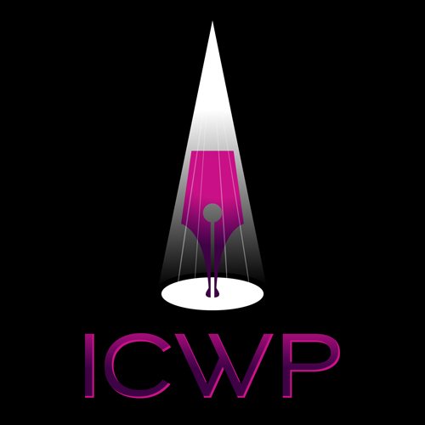

The 2013 International Centre for Women Playwrights 50/50 Applause Awards: ICWP “applauds” theatre companies for producing women playwrights.

Standing ovation! The International Centre for Women Playwrights (ICWP) is delighted with the increased number of recipients for this year’s 50/50 Applause Awards, which sets out to recognize theatres which produce 50% or more women playwrights in their season of shows. In the spring, members of ICWP nominated theatres that were producing the work of women playwrights throughout the world.

This year there are 29 recipients, nearly 6 times as many as our inaugural awards in 2012. The list includes theatres in the United States, India, Norway, Italy, and Canada. There are two repeat recipients: Playwrights Horizons in New York and Symmetry Theatre in California. President of ICWP, Dr. Jennifer Munday, says, “We are delighted with the response from both theatres and members who see this award as a demonstration of their commitment to women’s writing.”

Even though the indications are promising, ICWP recognizes there is a long way to go to 50/50 status. A study report from the Gender Equity Task Force in Chicago found that “Plays written by women (either one woman or a group of all women) constituted 18.8% of plays produced in Chicago….roughly in line with recent statistics from New York theaters and from Theatre Communications Group member theatres, which found that between 17% and 20% of plays produced by those groups are written by women.” (Chicago Storefront Summit, March 22, 2010) In two studies on the 2012-2013 season, Washington DC productions showed a slight uptick to 21% (DC Theater: A Demographic Analysis, 2013) and women playwrights were faring even better in Canada with 23%. (Playwrights Guild of Canada, 2013).

ICWP started in 1988 with a mission to support women playwrights worldwide and bring attention to their work. The 50/50 Applause Awards are now an annual event for ICWP, with nominations being stringently checked by a strong volunteer committee. More information about the awards can be found at: http://www.womenplaywrights.org/award

Contacts: Elana Gartner and Deborah Magid, co-chairs ICWP 50/50 Applause Awards Committee
Contact email address awards@womenplaywrights.org

Congratulations to the Recipients of the 2013 ICWP 50/50 Applause Awards:

AlterTheater (San Rafael, California, USA)
Black Coffee Productions (Bangalore, India)
Children's Theatre Company (Minneapolis, Minnesota, USA)
Clubbed Thumb (New York, New York, USA)
Dreamcatcher Repertory Theatre (South Orange, New Jersey, USA)
Factory Theatre (Toronto, Ontario, Canada)
Haugesund Teater (Rogaland, Haugesand, Norway)
HERE (New York, New York, USA)
Hollins University (Roanoke, Virginia, USA)
Indian Ensemble Theatre (Bangalore, India)
Looking for Lilith Theatre Company (Louisville, Kentucky, USA)
Mixed Blood Theatre (Minneapolis, Minnesota, USA)
New York Theatre Workshop (New York, New York, USA)
Orlando Repertory Theatre (Orlando, Florida, USA)
Playwrights Horizons (New York, New York, USA)
Prairie Theatre Exchange (Winnipeg, Manitoba, Canada)
Prologue Theatre Company (Chicago, Illinois, USA)
Ragged Wing Ensemble (El Cerrito, California, USA)
Road Less Traveled Productions (Buffalo, New York, USA)
Shameless Hussy Productions (Vancouver, British Columbia, Canada)
Stage Left Theatre (Chicago, Illinois, USA)
Stageworks Theatre (Tampa, Florida, USA)
Symmetry Theatre (Berkeley, California, USA)
Synchronicity Theatre (Atlanta, Georgia, USA)
Teatro Luna (Chicago, Illinois, USA)
Tennessee Women's Theatre Project (Nashville, Tennessee, USA)
The Cherry Lane Theatre (New York, New York, USA)
The English Theatre of Rome (Rome, Italy)
Theatre Pro Rata (Minneapolis, Minnesota, USA)

